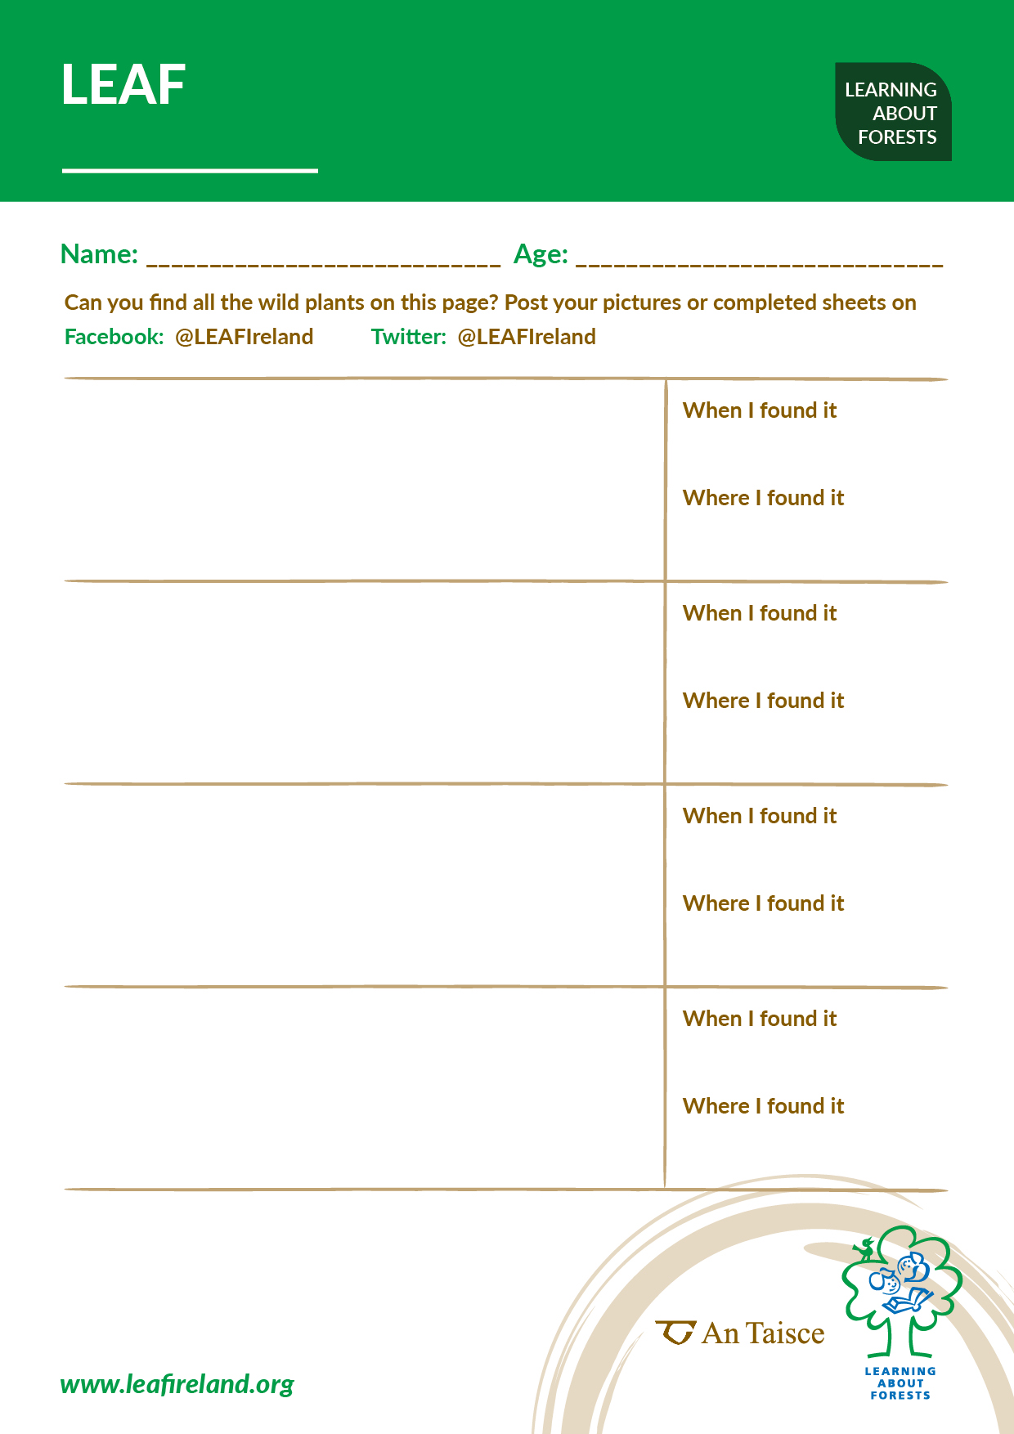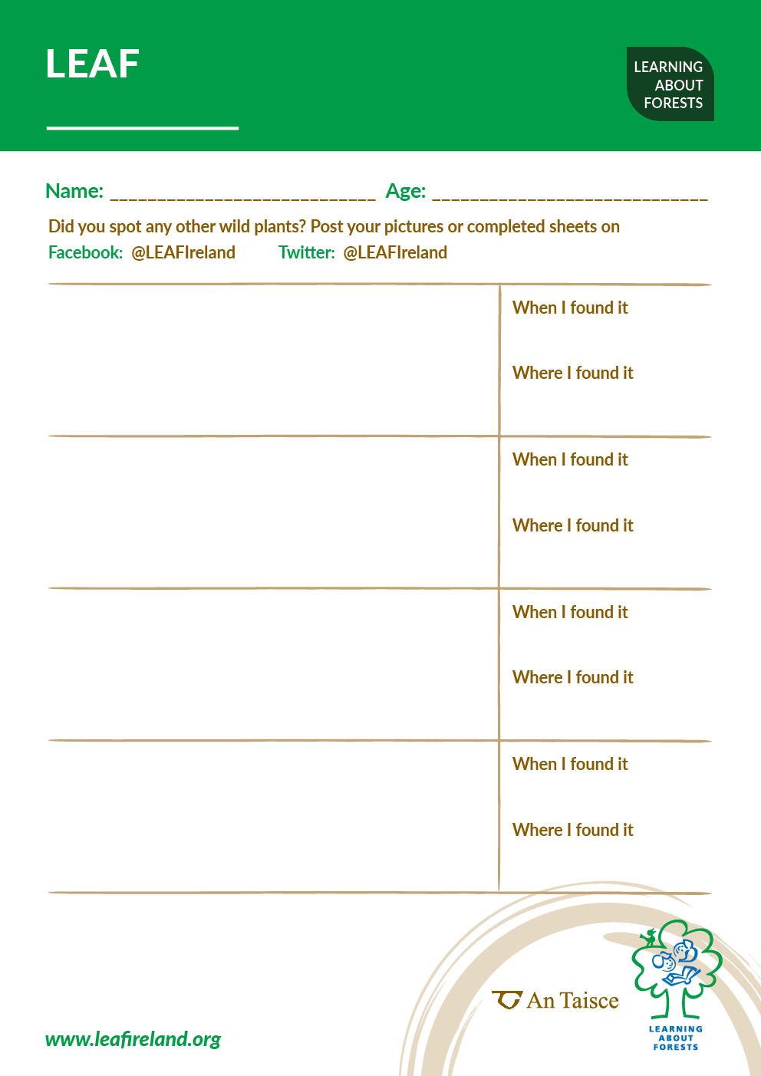

PLANT SPOTTER SHEET [insert month]





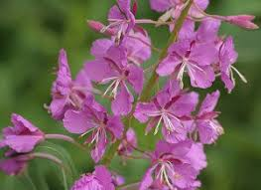

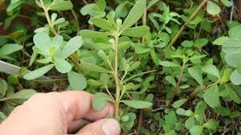

Item name *Edit each month*

Insert your text here

Insert your text here

Insert your text here

Insert your text here

Item name *Edit each month*

Insert your text here

Insert your text here

Insert your text here

Insert your text here

Item name *Edit each month*

Insert your text here

Insert your text here

Insert your text here

Insert your text here

Item name *Edit each month*

Insert your text here

Insert your text here

Insert your text here

Insert your text here